Unit Plan: [Title & Competency]
1.0 PROJECT OVERVIEW
Project title
School
Grade level
Discipline(s)
Start & end dates
Author(s)

Project summary (Include need/question driving student inquiry)
Culminating product/performance & audience
Other product(s) that students create as part of this project

2.0 PROJECT STANDARD ALIGNMENT
Projects/ Products | Standards | Success Criteria

UNIT DESIGN FRAMEWORK
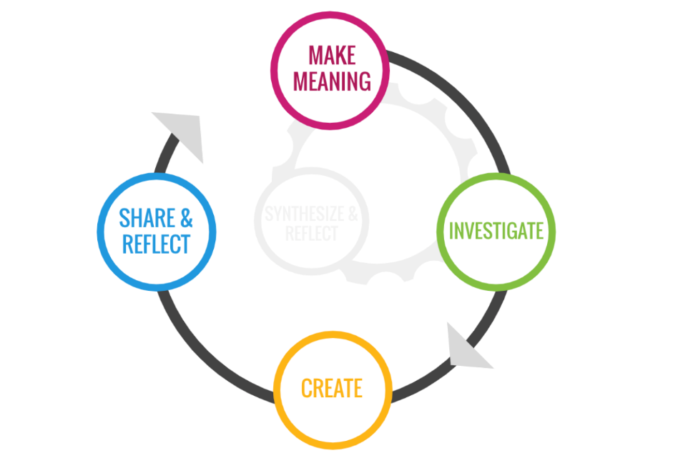

Read more about ReDesign’s take on the inquiry-based learning cycle here.

3.0 PROJECT MILESTONES
Milestone | Milestone | Milestone | Milestone | Milestone | Milestone
Formative Assessment | Formative Assessment | Formative Assessment | Formative Assessment | Formative Assessment | Formative Assessment

4.0 PROJECT CALENDAR (copy weekly calendar as needed)

Week of: | Milestone:
Day 1 | Day 2 | Day 3 | Day 4 | Day 5

Week of: | Milestone:
Day 1 | Day 2 | Day 3 | Day 4 | Day 5

